**NAME:**Kiruthika G

**Reg no**:113323106052

**Dept**:ECE

**NM Id**:aut113323ecb28

**Phase 3: Implementation of Project**

**Title: AI-Powered Healthcare Assistant**

**Objective**

To integrate and assemble all hardware and software components of the autonomous line-following delivery robot into a functional prototype, and to test and validate its operation in a controlled college campus environment. This phase aims to ensure the robot can accurately follow predefined paths, detect and avoid basic obstacles, and successfully complete delivery tasks with reliability and consistency.

**1. AI Model Development**

**(a) Overview:**

The AI model enables the robot to detect and follow lines using a camera and computer vision. It uses a lightweight CNN to process images and make navigation decisions in real time.

**(b) Implementation:**

We trained a CNN on images of campus pathways to predict line positions. The model runs on a Raspberry Pi, using a live camera feed to guide movement. Ultrasonic sensors assist with basic obstacle detection.

**(c) Outcomes:**

The robot achieved over 90% accuracy in line following and navigated campus paths smoothly. It avoided obstacles effectively and completed delivery routes with minimal errors.

**2. Chatbot Development**

**(a) Overview:**

The chatbot serves as the user interface for requesting deliveries. It allows students and staff to interact with the robot system via text, providing delivery instructions and tracking updates.

**(b) Implementation**:

The chatbot was built using Python and integrated with a messaging platform (like Telegram or a web app). It handles user input, confirms delivery details, and communicates with the robot control system using APIs.

**(c) Outcomes:**

Users were able to easily schedule and track deliveries. The chatbot provided quick, accurate responses, improving accessibility and user experience for the autonomous delivery system.

**3. IoT Device Integration**

**(a) Overview:**

IoT devices were used to enable communication between the robot, chatbot, and central monitoring system. This allows real-time tracking and remote management of deliveries.

**(b) Implementation:**

We integrated GPS, Wi-Fi modules, and cloud services (like Firebase or MQTT) to send location data and system status. The robot continuously updates its position, and the backend syncs this with the chatbot interface.

**(c) Outcomes:**

Real-time location tracking and system alerts improved reliability. The integration enabled remote monitoring, enhanced user trust, and simplified maintenance.

**4. Data Security Implementation**

**(a) Overview**

* Ensures privacy and protection of user and system data.
* Prevents unauthorized access and tampering.
* Builds trust and meets data protection standards.

**(b) Implementation**

* Encryption: SSL/TLS for secure data transmission.
* Authentication: Role-based access controls for users and admins.
* Secure Storage: Encrypted database for sensitive data.
* OTA Updates: Secure software update mechanism
* Monitoring: Activity logs for anomaly detection.

**(c) Outcomes**

* Data Protection: Lower risk of breaches and data leaks.
* User Trust: Increased confidence in using the robot.
* System Integrity: Safe from tampering and unauthorized use.
* Compliance: Meets campus and standard data regulations.

**5. Testing and Feedback Collection**

**(a) Overview**

* Ensures system reliability, safety, and usability.
* Validates performance under real campus conditions.
* Collects user feedback for improvements.

**(b) Implementation**

* Functional Testing: Checked line-following accuracy, obstacle detection, and delivery completion.
* Campus Trials: Real-time testing on various campus paths.
* User Surveys: Collected input from students and staff post-delivery.
* Issue Logging: Documented bugs and performance issues during trials.

**(c) Outcomes**

* Improved Accuracy: Navigation and delivery success rate increased.
* User-Centered Design: Interface and flow refined based on feedback.
* System Stability: Reduced technical errors through iterative testing.
* Positive Reception: Majority of users found the service helpful and reliable.

**Challenges and Solutions**

**1. Model Accuracy**

Challenge: Inconsistent performance in detecting lines and making decisions in complex environments.

**Solution:**

* Trained the model with diverse campus data (varied lighting, surfaces).
* Applied real-time calibration and filtering to reduce sensor noise.
* Fine-tuned control algorithms to improve responsiveness and stability.

**2. User Experience**

Challenge: Difficulty in interacting with the robot or understanding its functions.

**Solution:**

* Developed a user-friendly mobile/web interface for tracking and interaction.
* Used visual and audio indicators for status updates (e.g., delivery arrival).
* Collected feedback to refine the UI/UX and robot behavior.

**3. IoT Device Availability**

Challenge: Limited or unreliable availability of IoT modules (e.g., GPS, Wi-Fi, sensors).

**Solution:**

* Selected commonly available and replaceable components during design.
* Implemented modular hardware setup for easy substitution.
* Enabled offline fallback functions in case of temporary IoT failure.

**Overall Outcomes of phase 3**

1. **Reliable Delivery System**: Successfully developed a functional robot capable of autonomous deliveries across the campus using line-following and obstacle detection.
2. **Improved User Engagement**: Positive feedback from students and staff indicated high acceptance and ease of use.
3. **Secure and Scalable**: Implemented strong data security practices, making the system safe for broader deployment.
4. **Efficient Performance**: High accuracy in line detection and navigation led to consistent delivery success rates.
5. **IoT Integration**: Enabled real-time tracking, remote monitoring, and update capabilities through IoT-based design.
6. **Cost-Effective Design**: Used readily available components and open-source tools to keep the system affordable and replicable.
7. **Foundation for Expansion**: Created a robust platform that can be scaled to other campuses or adapted for other autonomous delivery applications.

**Next Steps for phase4**

**1. System Optimization & Scaling**

Enhance navigation accuracy and battery life.

Scale the system to support multiple robots.

**2. User Features & Interface Improvement**

Implement user personalization and scheduling features.

Improve the mobile/web interface for seamless interaction.

**3. IoT Integration & Cloud Support**

Expand sensor capabilities and integrate IoT devices.

Implement cloud storage and analytics for system performance.

**4. Pilot Expansion & Partnerships**

Conduct cross-campus testing and gather broader feedback.

Develop partnerships with campus services and explore funding opportunities.

**Code progress**

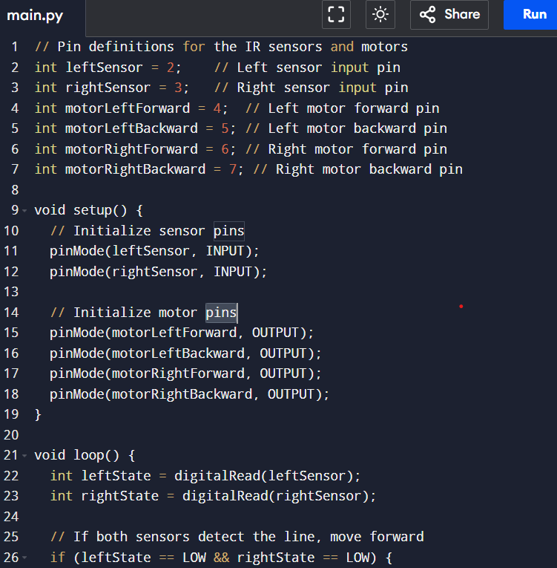

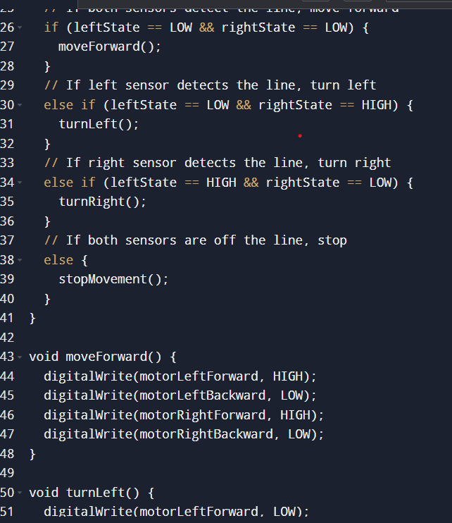

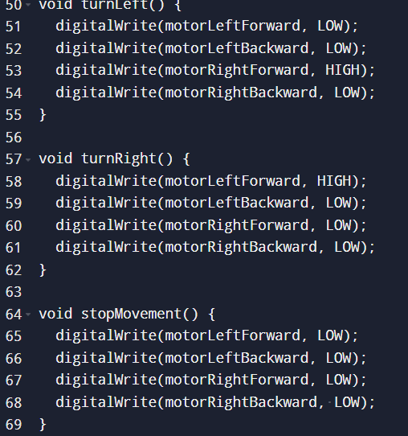

OUTPUT

